EE3060 Probability – Proposed questions and answers

Question 1:

There’s a kid has three box of chocolate bar. One day, he is hungry and want to eat a chocolate bar from one of three box.

Box 1: 10 chocolate bars inside.

Box 2: 15 chocolate bars inside.

Box 3: 20 chocolate bars inside.

Calories per chocolate bar in Box1: 100 cal

Calories per chocolate bar in Box2: 150 cal

Calories per chocolate bar in Box3: 200 cal

Let X be the calories he get this time, Y be the box number ( Y = y, where Y ={1,2,3} ) of the box he chooses.

(1) derive 𝐸[𝑋]

(2) list all 𝐸[𝑋|𝑌]

(3) show that 𝐸[𝐸[𝑋|𝑌]] = 𝐸[𝑋]

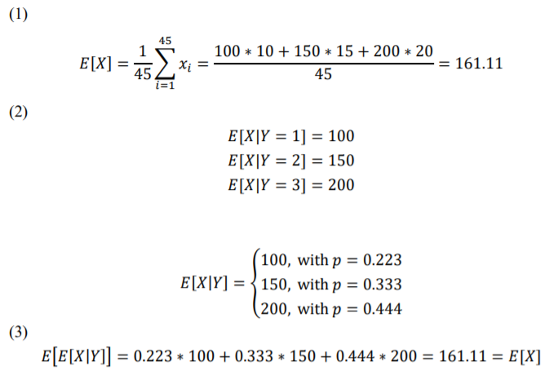Answer 1:

Question 2:

Let X and Y be independent random variables, uniformly distributed in the interval [0,1]. Find the CDF and PDF of |X-Y|

Answer 2:

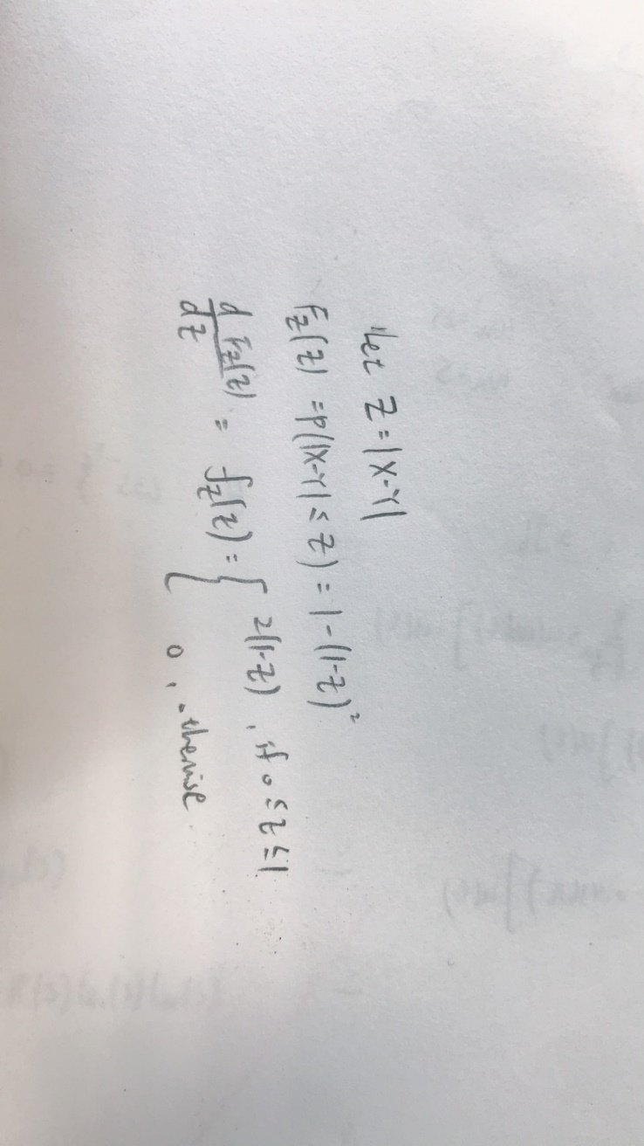

Question 3:

Generalize part (b)(ii) to compute the variance of the sum of X + Y + Z of three random variables in terms of the variances of X, Y , and Z as well as the covariances between each of the random variables. What happens when X, Y, Z are mutually independent?

Answer 3:

Using our answer from part (b) we can write Var(X + Y + Z) = Var(X + Y ) + Var(Z) + 2 · Cov(X + Y, Z) = [Var(X) + Var(Y ) + 2 · Cov(X, Y )] + Var(Z) + 2 · E[(X + Y − µx − µY )(Z − µZ)] We can expand out the last term in the previous line as E[(X + Y − µx − µY )(Z − µZ)] = E[(X − µx)(Z − µZ) + (Y − µY )(Z − µZ)] = Cov(X, Z) + Cov(Y, Z) Plugging back into our previous equation we have Var(X + Y + Z) = Var(X) + Var(Y ) + Var(Z) + 2Cov(X, Z) + 2Cov(Y, Z) + 2Cov(X, Z) If X, Y, Z are mutually independent, then Cov(X, Z) = Cov(Y, Z) = Cov(X, Z) = 0, hence Var(X + Y + Z) = Var(X) + Var(Y ) + Var(Z)

Question 4:

The aisle is 1km long, there are two students who are asked to choose two point to hung there painting randomly. Find the expect distance between the two painting.

Answer 4:

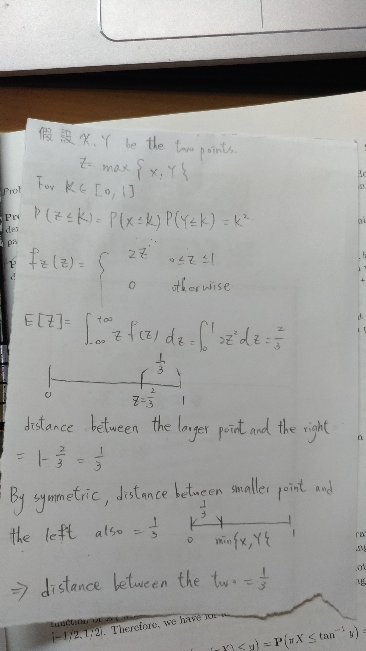

Question 5:

Given the joint density function of X, Y as below:

$$f_{XY}\left(x,y\right)=\left\{\begin{aligned}\frac{x+4y}{a}, 0≤x≤4, 0≤y≤2 \\ 0, otherwise\end{aligned}\right.$$

1. ) find the value of a.
2. ) find the covariance of X & Y, $Cov\left(x,y\right).$

Answer 5:

a.

$\int_{0}^{2}{\int_{0}^{4}{\frac{x+4y}{a}dxdy=1}}$, $\int_{0}^{2}{\int_{0}^{4}{\frac{x+4y}{a}dxdy=\frac{48}{a}}}$, $a=48$

b.

$$f_{X}\left(x\right)=\int_{0}^{2}{\frac{x+4y}{48}}dy=\frac{x+4}{24}$$

$$f_{Y}\left(y\right)=\int_{0}^{4}{\frac{x+4y}{48}}dx=\frac{2y+1}{6}$$

$$E\left[X\right]=\int_{0}^{4}{x*\frac{x+4}{24}}dx=\frac{20}{9}$$

$$E\left[Y\right]=\int_{0}^{2}{y*\frac{2y+1}{6}}dy=\frac{11}{9}$$

$$E\left[XY\right]=\int_{0}^{2}{\int_{0}^{4}{xy*\frac{x+4y}{48}}}dxdy=\frac{8}{3}$$

$$Cov\left(X,Y\right)=E\left[XY\right]-E\left[X\right]E\left[Y\right]=\frac{8}{3}-\left(\frac{20}{9}*\frac{11}{9}\right)=-\frac{4}{81}$$